IT203

Signifi Email Signature setup

|  |  |
| --- | --- |
| Status | Final |
| Version | 1.03 |
| Classification | Confidential |
| Owner | Razvan Anghelidi, Directory of IT |
| Address | 1705 Tech Avenue, Unit 2-3, Mississauga, ON, L4W 0A2, Canada |

*Statement of Confidentiality: This document and supporting materials contain confidential and proprietary business information of Signifi Solutions Inc. These materials may be printed or photocopied for use internally and must not be shared with other parties.*

1. Signifi Solutions Inc. email stationery setup instructions 4

2. Example 4

3. Your signature 5

4. Revision History 9

All rights reserved

No part of this document may be reproduced in any form, including photocopying or transmission electronically to any computer, without prior written consent of Signifi Solutions (from now on, Signifi). The information contained in this document is proprietary to Signifi and may not be used or disclosed except as expressly authorized in writing by Signifi.

Trademarks

Other product names mentioned in this document may be trademarks or registered trademarks of their respective companies and are hereby acknowledged.

Document Control

The electronic version of this document is recognized as the only valid version.

Approval History

|  |  |  |
| --- | --- | --- |
| APPROVER(S) | TITLE/DEPARTMENT | APPROVED DATE |
| Britt Swan | VP Customer Success | 2022-05-25 |
| Shamira Jaffer | CEO | 2020-06-17 |
|  |  |  |
|  |  |  |

Document Sensitivity Level

Confidential

1. Signifi Solutions Inc. email signature setup instructions

This document aims to assist employees to setup their email signatures to ensure a consistent brand throughout the organization. Please follow the instructions on the next page to ensure that your signature is correctly applied. No other versions of email signatures are permitted from June 1, 2022.

1. Example

THIS IS AN EXAMPLE TO ALLOW YOU TO COMPARE YOUR FORMATTING BEFORE YOU COPY THE TABLE (please personalize on the next page)

|  |  |
| --- | --- |
|  | **Shamira Jaffer**  CEO  **CA**, US, FR, UK, DE, SE    **e.** [sjaffer@signifi.com](mailto:sjaffer@signifi.com) **m.** +1-416-618-3454  **t.** 1 (877) 744 6434 **w.** [signifi.com](https://signifi.com/) |

1. Your signature

Update the following table with your own official details:

|  |  |
| --- | --- |
|  | **Shamira Jaffer**  CEO  **CA**, US, FR, UK, DE, SE    **e.** [sjaffer@signifi.com](mailto:sjaffer@signifi.com) **m.** +1-416-618-3454  **t.** 1 (877) 744 6434  **w.** [signifi.com](https://signifi.com/) |

**Follow these step-by-step guidelines for the perfect outcome:**

1. The Signifi logo and the four-accreditation logos remain unchanged (as one image).
2. Your **full name** must be bold
3. Update your **designation** as per the Outlook’s contact card (hover over your name in a new email, and the card pops up), or as approved by your manager.
4. To update the **country** from where you operate, please use ‘format painter ’ to change the color to red. The other countries will remain grey.
5. Update your **email and mobile number**. Office. The toll-free number and website (along with the link - https://www.signifi.com/) remain the same.
6. Add **social media links** for each icon as follows:

* LinkedIn <https://www.linkedin.com/company/signifi-solutions-inc./mycompany>
* Facebook <https://www.facebook.com/signifisolutionsinc/>
* Twitter <https://twitter.com/teamsignifi>
* Instagram <https://www.instagram.com/signifi_solutions_inc/>
* YouTube <https://www.youtube.com/channel/UCvSLfWspOiw7TE9Y-1AcDPg/featured>

1. Once the above is updated, copy the entire table, and Open Outlook to complete the remaining actions
2. Select **New Email**  
   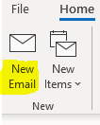
3. Select **Signature** at the top navigation panel:  
   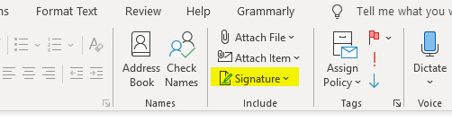
4. Then select **New:**  
   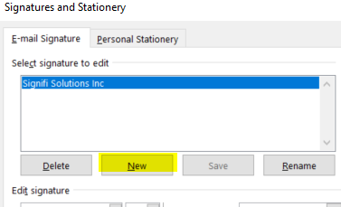
5. Type in a **Name** for your signature:  
   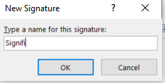
6. Finally, **paste** your personal signature, and **‘Save’.**
7. Select where you want to display your signature: **New Messages** and/or **Replies/Forwards**. You may select both, but **New messages** option is advised.

1. Please **note** the following:

* Please ensure that all your changes are completed in this word document before you try to move your information over to Outlook
* Ensure the size ratios, position and spaces have not changed.
* Windows has the ability to change fonts where they don’t need to. Once you’ve updated your details, select the entire signature, and change the font to **Calibri**
* Ensure the links for the social media links are intact. If they’re broken, you can set them again from the Signature box itself from here: 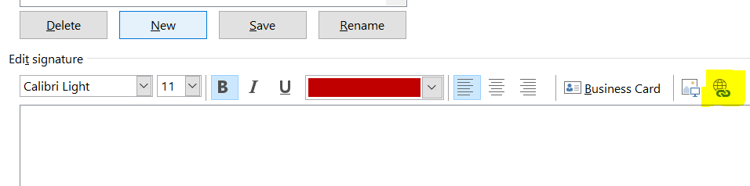
* **TEST** the signature by applying it in a new email.

Additionally, you can ask IT to assist [it@signifi.com](mailto:it@signifi.com).

Approval/ Revision History

|  |  |  |  |
| --- | --- | --- | --- |
| VERSION | DATE | SUMMARY OF CHANGE | CHANGED BY |
| 1.01 | 2020-06-17 | First Document | Shamira Jaffer |
| 1.02 | 2020-06-22 | Small updates | Shamira Jaffer |
| 1.03 | 2022-05-06 | Revision, ADA compliant & standardization | Jamie McDowell |